

American International University-Bangladesh (AIUB)  
**Department of Computer Science  
Faculty of Science &Technology (FST)  
Fall 19_20**

**Section: J  
Group No:**

**PROJECT TITLE**

A software Engineering project submitted

By

*Abdullah Al Mamun Shiam(18-37075-1)(* [*https://github.com/shiamabdullah/*](https://github.com/shiamabdullah/)*)*

*Showmik Roy (Student ID)(Git Account)*

*Md. Shahriar Islam (18-37007-1)(shahriar-rafat)*

**PROJECT LINK**

*<https://github.com/shiamabdullah/Credit-Card-Management-System>*

The project will be evaluated for the following Course Outcomes

|  |  |
| --- | --- |
| CO3: Choose appropriate software engineering model in a software development environment | Total Marks |
|  |
| Project Background Analysis (needs, goal, benefits, etc.) [5Marks] |  |
| Appropriate Process Model Selection [5Marks] |  |
| Argumentation for model selection with Evidence [5Marks] |  |
| Completeness, Spelling, Grammar and Organization of the Answer [5Marks] |  |
|  | |
| CO4: Explain the roles and their responsibilities in the software project management activities | Total Marks |
|  |
| Content Knowledge (e.g. System Requirements, System Design) [5Marks] |  |
| Project Role identification [5Marks] |  |
| Responsibility Description [5Marks] |  |
| Completeness, Spelling, grammar and Organization of the Answer [5Marks] |  |

Contents

1. PROBLEM DOMAIN 4

1.1 Background to the Problem 4

1.2 Solution to the Problem 4

1.3 Existing / Related Solutions 4

2. SOFTWARE DEVELOPMENT LIFE CYCLE 5

2.1 Process Model 5

2.2 Project Roll Identification and Responsibilities 5

3. PRODUCT AND PROJECT DESCRIPTION 6

3.1 Stakeholders 6

3.2 System Features 6

4. System Quality Attributes 8

4.1 System Architecture 8

4.2 System Interface 10

4.3 Project Requirements 19

# 1. PROBLEM DOMAIN

## Background to the Problem

Credit cards have become a day to day thing in our life. In first world countries almost nobody buys a house or a new car in cash, so sooner or later you’re going to have to use credit to obtain the things you want in life. It’s spread in our country as well. We can buy things on EMI, get ready cash on instance through this.

Services received from our country’s companies are not sufficient enough. If a user loses a credit card he has to face a lot of complicated steps for verification. Besides, getting a credit card is not user friendly as well. It’s a long term hefty process. This is the root problem we are trying to solve.

## Solution to the Problem

We are like a bridge between the banks, user and government. With most of the affiliated banks and government we have access to their data.

From our app user can issue a credit card, get credit card when it’s lost for the stored cards in our inventory. User can verify themselves once in our app with national id card. Even teenagers can get an account with their birth id card.

Our goal is to make the entire system as easy and user friendly as possible.

## Existing / Related Solutions

Many banks have incorporated our features in their system.

But as we know a person has cards from different banks. With just one click our users can access any of their cards. And get all the services with in.

# SOFTWARE DEVELOPMENT LIFE CYCLE

## 2.1 Process Model

## Here we follow the FDD process model. This is an agile framework that, as it’s name suggests, organizes software development around making progress on features. Feature in the FDD context are not necessarily product features in the commonly understood sense.

* As we work in a team and our time is short ,so we think that if we follow FDD process model then we can finish timely. And another benefit is that we can change our project feature and add any feature anytime by our following process model. That’s the extra benefit for us.

## 2.2 Project Roll Identification and Responsibilities:

* In our project we have followed five steps rules. At first we developed the overall model, then we built the feature list, every project work planned by feature even designed by feature and build by feature. We distributed our work among all three members of our group. We continued our works in plan base way. We also help each other when any group member fall in problem. Our target was finished our project intime. And we also make our project changeable. We will be able to change .
* Successful development projects take careful planning, a talented team and collaboration of a project’s team members, both internal and external. Software projects only move forward whey the key team members are in place. Responsibilities are divided into all the group member.

1. **Team Leader**: Develop the project plan. Manage deliveries according to the plan. And he also lead the project team.
2. **Members**: Generally the work according to their leader’s direction. Team leader gives them target to fulfill the their distributed feature development and try to finish in time. And member also collaborate with other members in the team. They can also take any problem’s solution from their team leader.

# PRODUCT AND PROJECT DESCRIPTION

## 3.1 Stakeholders

* Team
* User
* Government
* Bank
* Management

## System Features

1. System Login   
   1. Login is Randomized for everyone. If user enters his id and password he will be referred to user page, if admin enters credentials he’ll be referred to admin page same goes for CEO. Every one can login using the same portal.  
   2. During login user password is hidden. There is also an option for visibility.  
     
   Priority Level: High  
   Precondition: Have to have an account with valid user id and password. System SignUp id prerequisite for Login.
2. System Signup   
   1. User can sign up here. Admin and super admin can’t signup. Admin account can only be created by the super admin.  
   2. Insert all credentials like user name, user id, father’s name, mother’s name, government id card details, phone number etc.  
   3. If an exiting id of the same id name remains system signup can’t be done. This will be checked runtime on the sign up page.  
     
   Priority Level: High  
   Precondition: Must give all credentials. Have to have valid government id card. All data have to be valid and all.
3. Add Document   
   1. User Can add card and data here. They can store them. Only verified cards by banks affliated to user accounts can be added.  
   Priority Level: High  
   Precondition: Have to h
4. Issue Card   
   1 User can apply for card here. He has to wait for the admin before the request is processed.

Priority Level: High  
Precondition: Must have a user account

1. Reset Password   
   1 Everyone can change his user id’s password. For this first of all they need to be signed up to their account.

2 Need to enter previous password. Then the system will check while the old passwords match.

3 If old password match then the password change request if processed.

Priority Level: High  
Precondition: Must have to enter previous password

1. Update Issued Card

1 Admin can issue a card

2 All data should be crosschecked with bank

3 When card issued user card details will be updated automatically

Priority Level: High

Precondition: User must apply for a card first

# System Quality Attributes

Our system is user friendly, fast and reliable. We think every body can understand our system process easily. They will feel very flexible to use software. Every single person can use our software very easily. And we think it will be very helpful software for the customer. And they will get everything on their hand that’s why they don’t need to go outside home .It is easy to maintain our software ,that’s why customer don’t need to take extra pain. Another benefits is that our software have testability, so that if they fall any problem we can test and give a solution easily. Customer can also reuse our software.

## 4.1 System Architecture

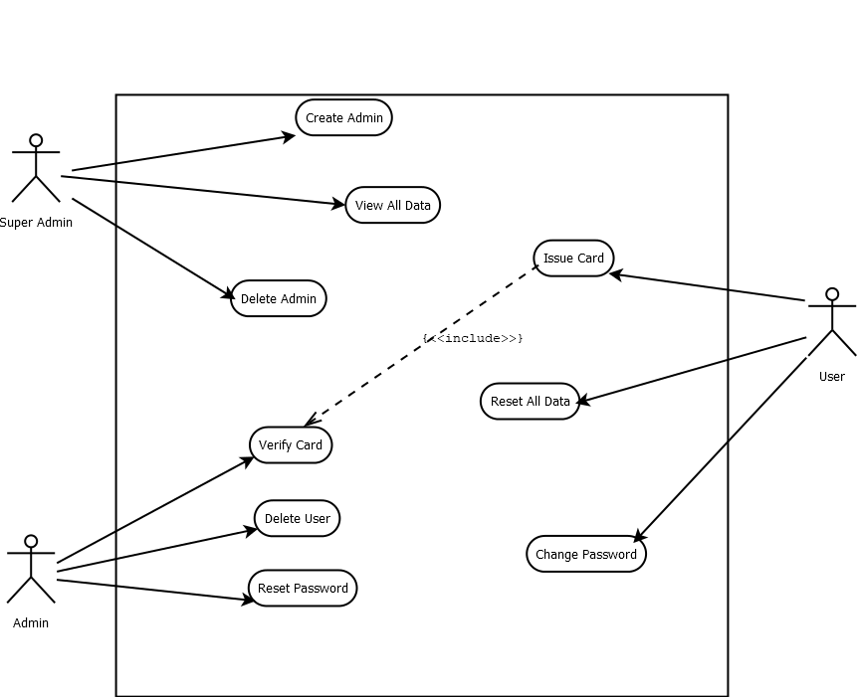

Fig 4.1.1 : Use Case Diagram

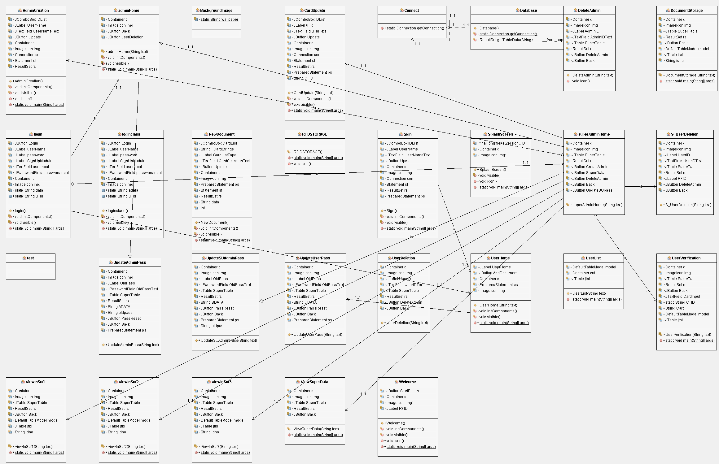

4.2.1 : Class Diagram 1

## 4.2 System Interface

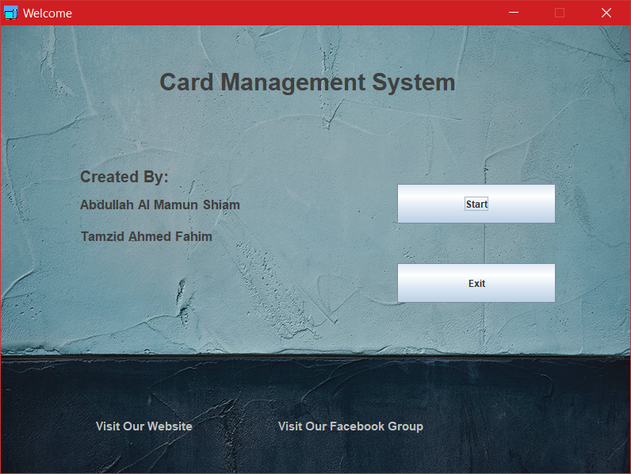

Fig 4.2.1 Welcome

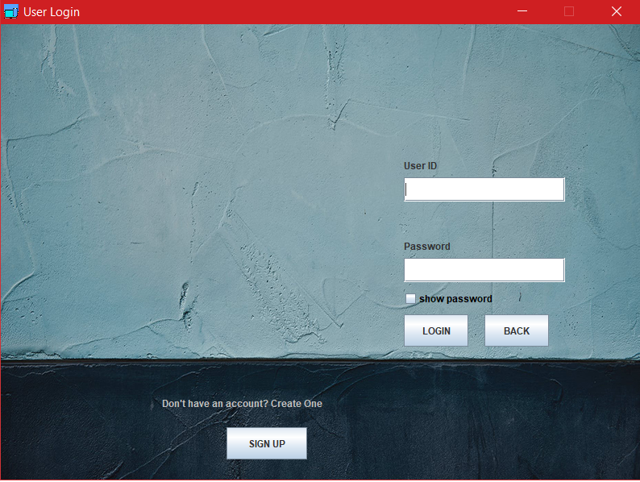

Fig 4.2.2 Login

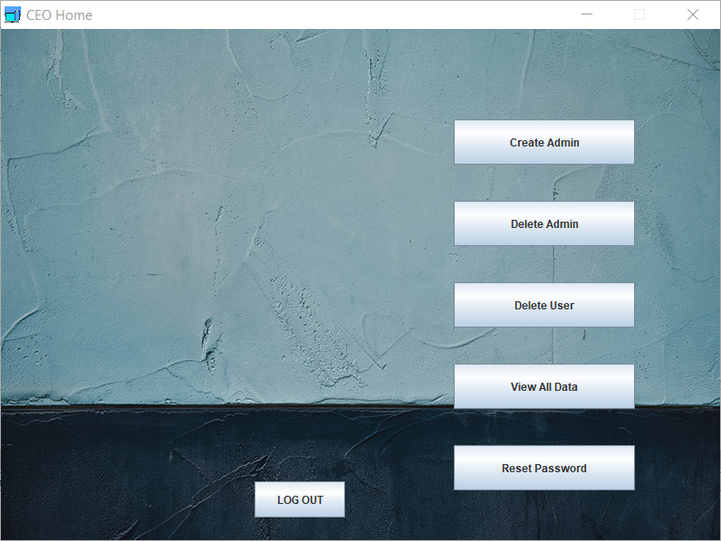

Fig 4.2.3 Super Admin

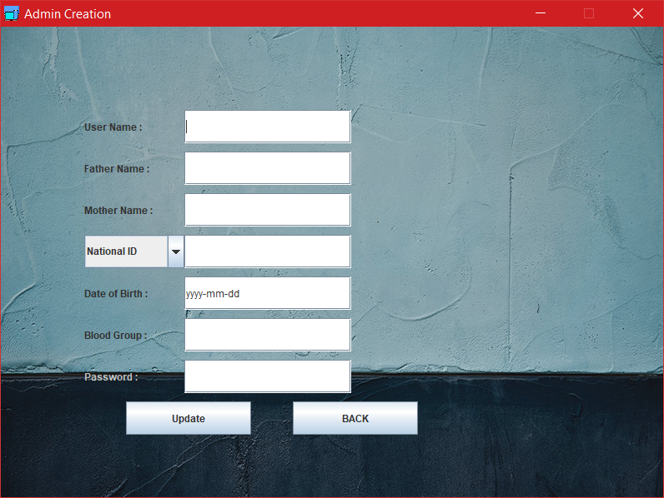

Fig 4.2.4 Admin Creation

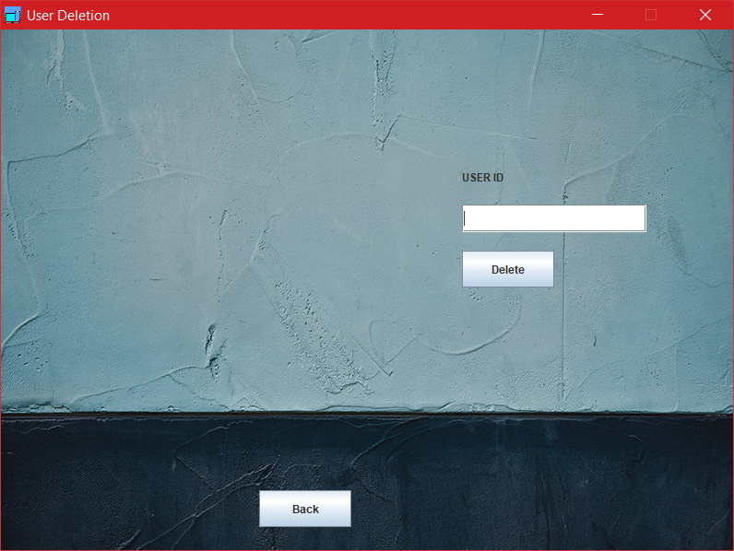

Fig 4.2.5 User Deletion

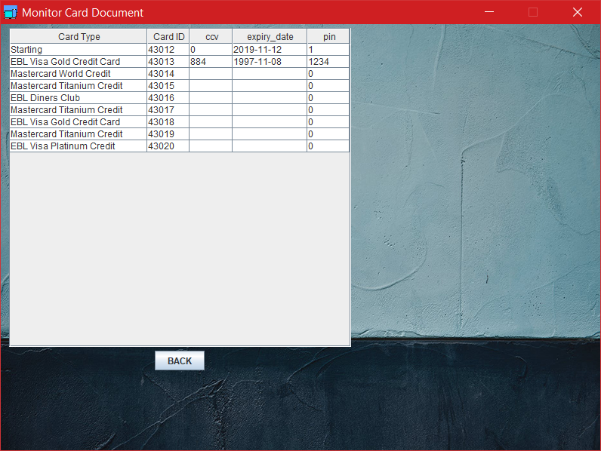

Fig 4.2.6.Monitor Card

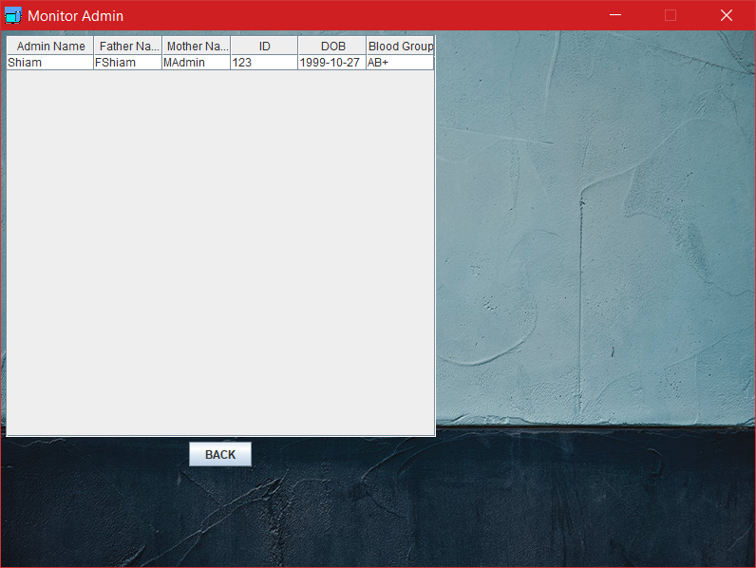

Fig 4.2.7.Monitor Admin

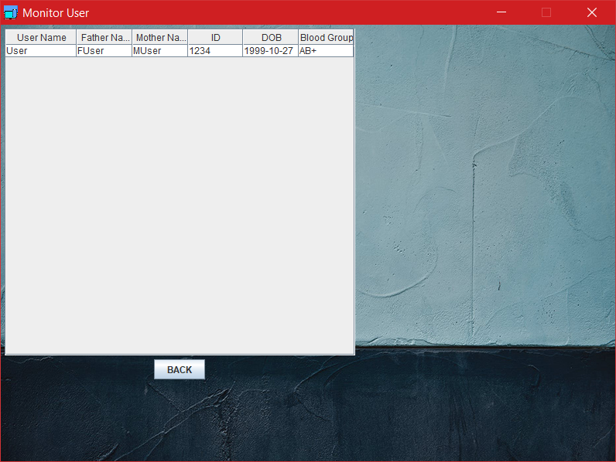

Fig 4.2.8.Monitor User

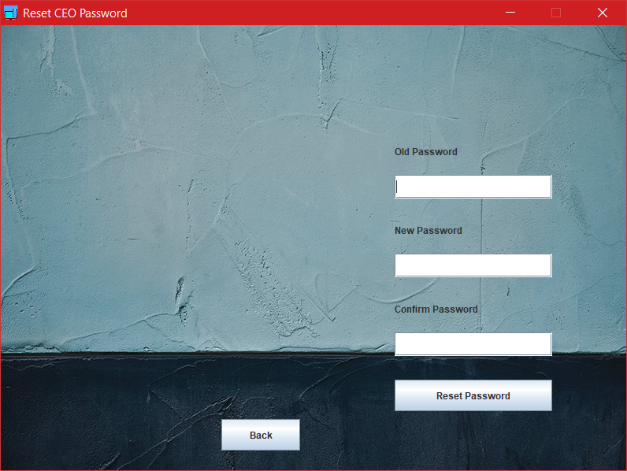

Fig 4.2.8. Reset CEO Password 1

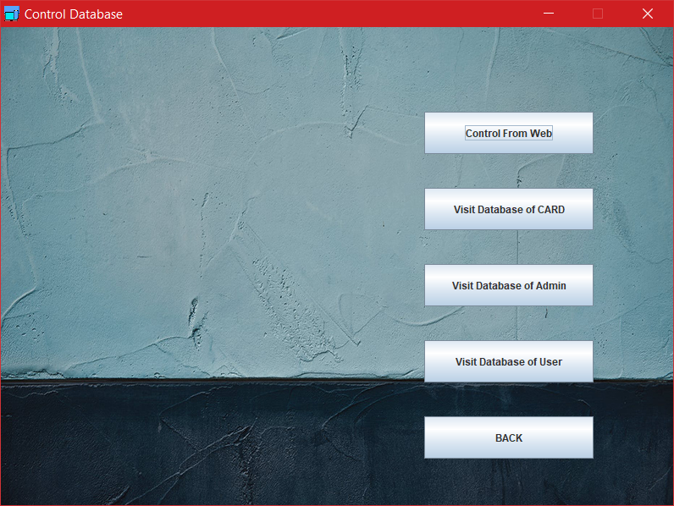

Fig.4.2.9.Control Databse

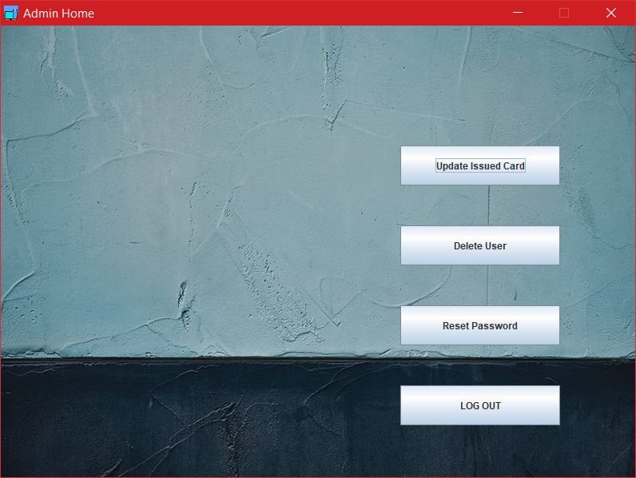

Fig.4.2.10. Admin Home

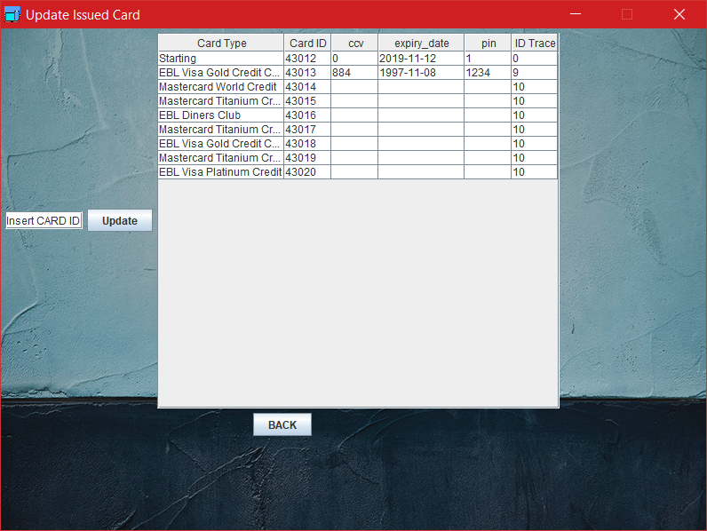

Fig.4.2.11 Issue card



Fig.4.2.12 User Deletion

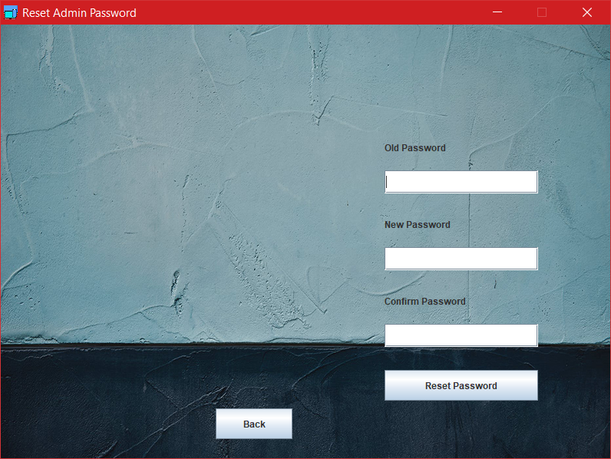

Fig.4.2.13 Reset Admi password



Fig 4.2.15 Update Issue Card 1

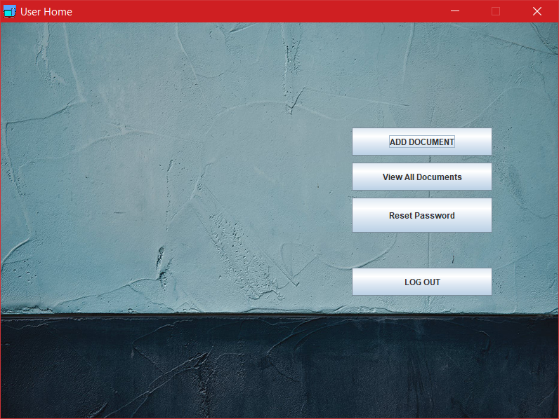

Fig.4.2.16 User Home

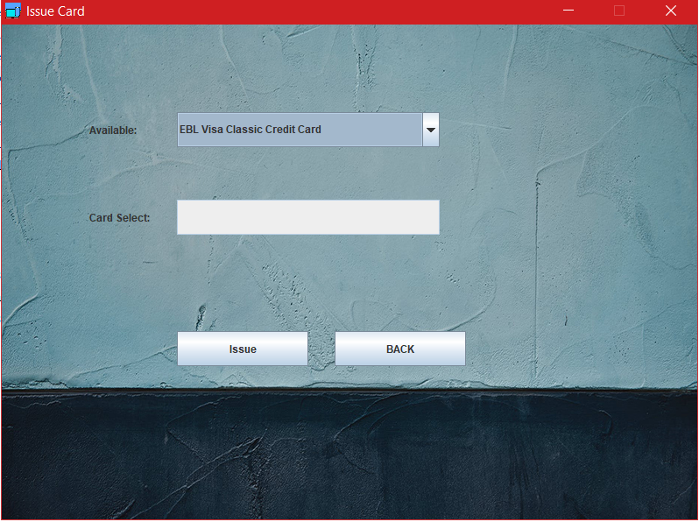

Fig.4.2.17.Issue Card

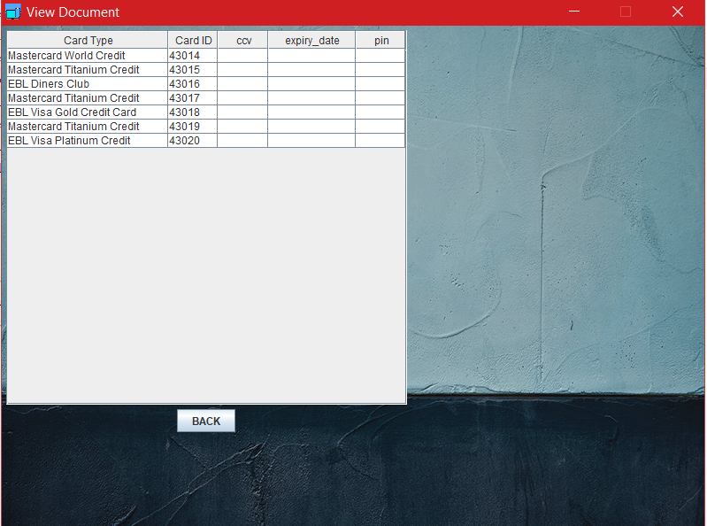

Fig.4.2.18.User Database 1

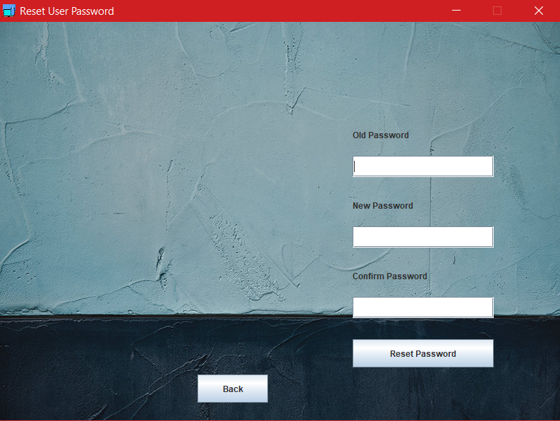

Fig.4.2.19 Reset User Password

## 

## 4.3 Project Requirements

Calculated using the COCOMO model. We have considered out software to be Organic. As our team size is small.

* Source Lines of Code (SLOC) : 3245
* Effort (PM) : 8.26 person-months
* Development Time (DM) : 5.57 months
* Average Staffing Necessary (ST): 1.48 person

**References**

* ***R.S. Pressman & Associates, Inc. (2010). Software Engineering: A Practitioner’s Approach.***
* ***Kelly, J. C., Sherif, J. S., & Hops, J. (1992). An analysis of defect densities found during software inspections. Journal of Systems and Software, 17(2), 111-117.***